1. What does the getElementbyId () method do?
   1. It is used to grab an element from the DOM. The getElementbyId method takes an id and returns the element that has that id.
   2. Element/ element object: it is the browser’s internal representation of what type into your HTML file, such as <p>…text….</p>. When the browser loads and parses the HTML file, it creates an element object for every element in the page and adds all those element objects to the DOM.
2. What does the innerHTML element do?
   1. The innerHTML property is used to read or replace the content of an element. When looking at the value of innerHTML, it will be noticed the content contained within the element, not including the HTML element tags.
   2. E.g.

<script>

          var access = document.getElementById("code9");

          var code = access.innerHTML;

          code = code + " midnight";

      alert(code);

      </script>

* 1. In the example above, I will update the content within the element that has Id “code9” by simply adding the text “midnight” and show the result in an alert box.

1. What does the document object do?
   1. The document object is used to get access to the DOM from our code. The document object is a built-in object that comes with a bunch of properties and methods, including getElementById.
2. Review the code on page 230. How would I alter the code.js file to get the code8 element and add the word “rise” to it and return it in an alert window?
   1. Here is the code:

<script>

            var access = document.getElementById("code8");

            var code = access.innerHTML;

            code = code + " rise";

alert(code);

      </script>

* 1. Here is the output

1. Review the code on page 236, draw a DOM and insert it here.

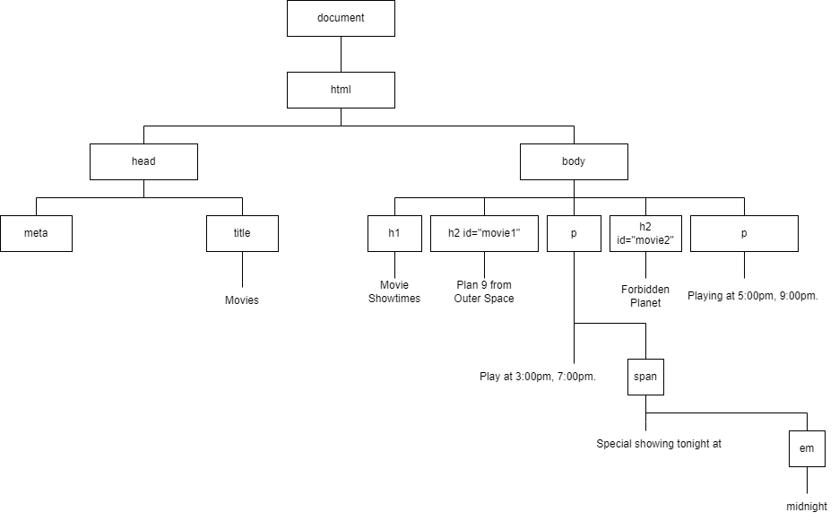

1. For the code on page 236, how would I alter the code to make sure that the movie2 element displays the text color in red for this line: “Playing at 5:00 pm, 9:00 pm”?
   1. As in page 257, I will assign an id name to the required paragraph tag.
   2. From this id, I will use setAttribute method to insert a class name to this specific element that contains the required text.
   3. Here is an example for the code:

* 1. And here is the output:

1. Describe how an event handler works in the browser.
   1. If there is a big important event that’s going to occur, and you definitely want to know about it, Say that event is the “page is loaded” event. A common way to deal with that situation is through a callback, also known as an **event handler**
   2. A callback works like this: give a function to the object that knows about the event. When the event occurs, that object will call you back, or notify you, by calling that function. You’re going to see this pattern in JavaScript for a variety of events.
   3. You can use the window object’s onload property to set an **event handler** or callback function for the load even.
2. How does the getAttribute method work? Show me an example of it in a line of code in JavaScript.
   1. You can get the **value** of an element’s attributes using the **getAttribute** method.
   2. Here is a code example:

* 1. Here is the output:

1. How does the setAttribute method work? Show me an example of it in a line of code in JavaScript.
   1. You can set the value of an element’s attributes using the setAttribute method
   2. There is a pretty descriptive example was provided in this assignment in question #6 but here is another one inserting a src attribute for an img tag:

* 1. Here is the output:

1. What is the DOM?
   1. The **DOM** or **Document Object Model** is the browser’s internal representation of your web page.
   2. The browser creates the DOM for your page as it loads and parses the HTML.
   3. You can get access to the DOM in your JavaScript code with the document object. e.g. document.getElementById(“id”).